**Policy PoP-06**

**External Policing Assistance**

Approved 25 September 2025

**Purpose**

1. The Board is legislatively required to ensure the Provision of Adequate & Effective Policing in Halton Region. Based on its assessment of Community needs, values and expectations, the Board determines which policing functions should be inherent to the HRPS, which are best provided by other policing agencies, and which require a combination of both approaches. Refer to Step A in the figure below (from policy PoP-01 Provision of Adequate & Effective Policing).
2. Where the Board deems that a policing function is best provided by another policing agency on an ongoing or frequent basis, in full or in part, the Board must establish a standing **Policing Assistance Agreement** with that agency(s), as per section 14 of the CSPA. Refer to Step B in the figure below.
3. Additionally, the Chief of Police may request **Temporary Policing Assistance** (under section 19 of the CSPA) beyond the scope of the Policing Assistance Agreements. The Chief must inform the Inspector General and the Board of such requests, and the Board must subsequently consider whether those policing functions should become inherent to the HRPS or otherwise be provided through new standing Assistance Agreements (Step C),and adjust direction accordingly (Step D).

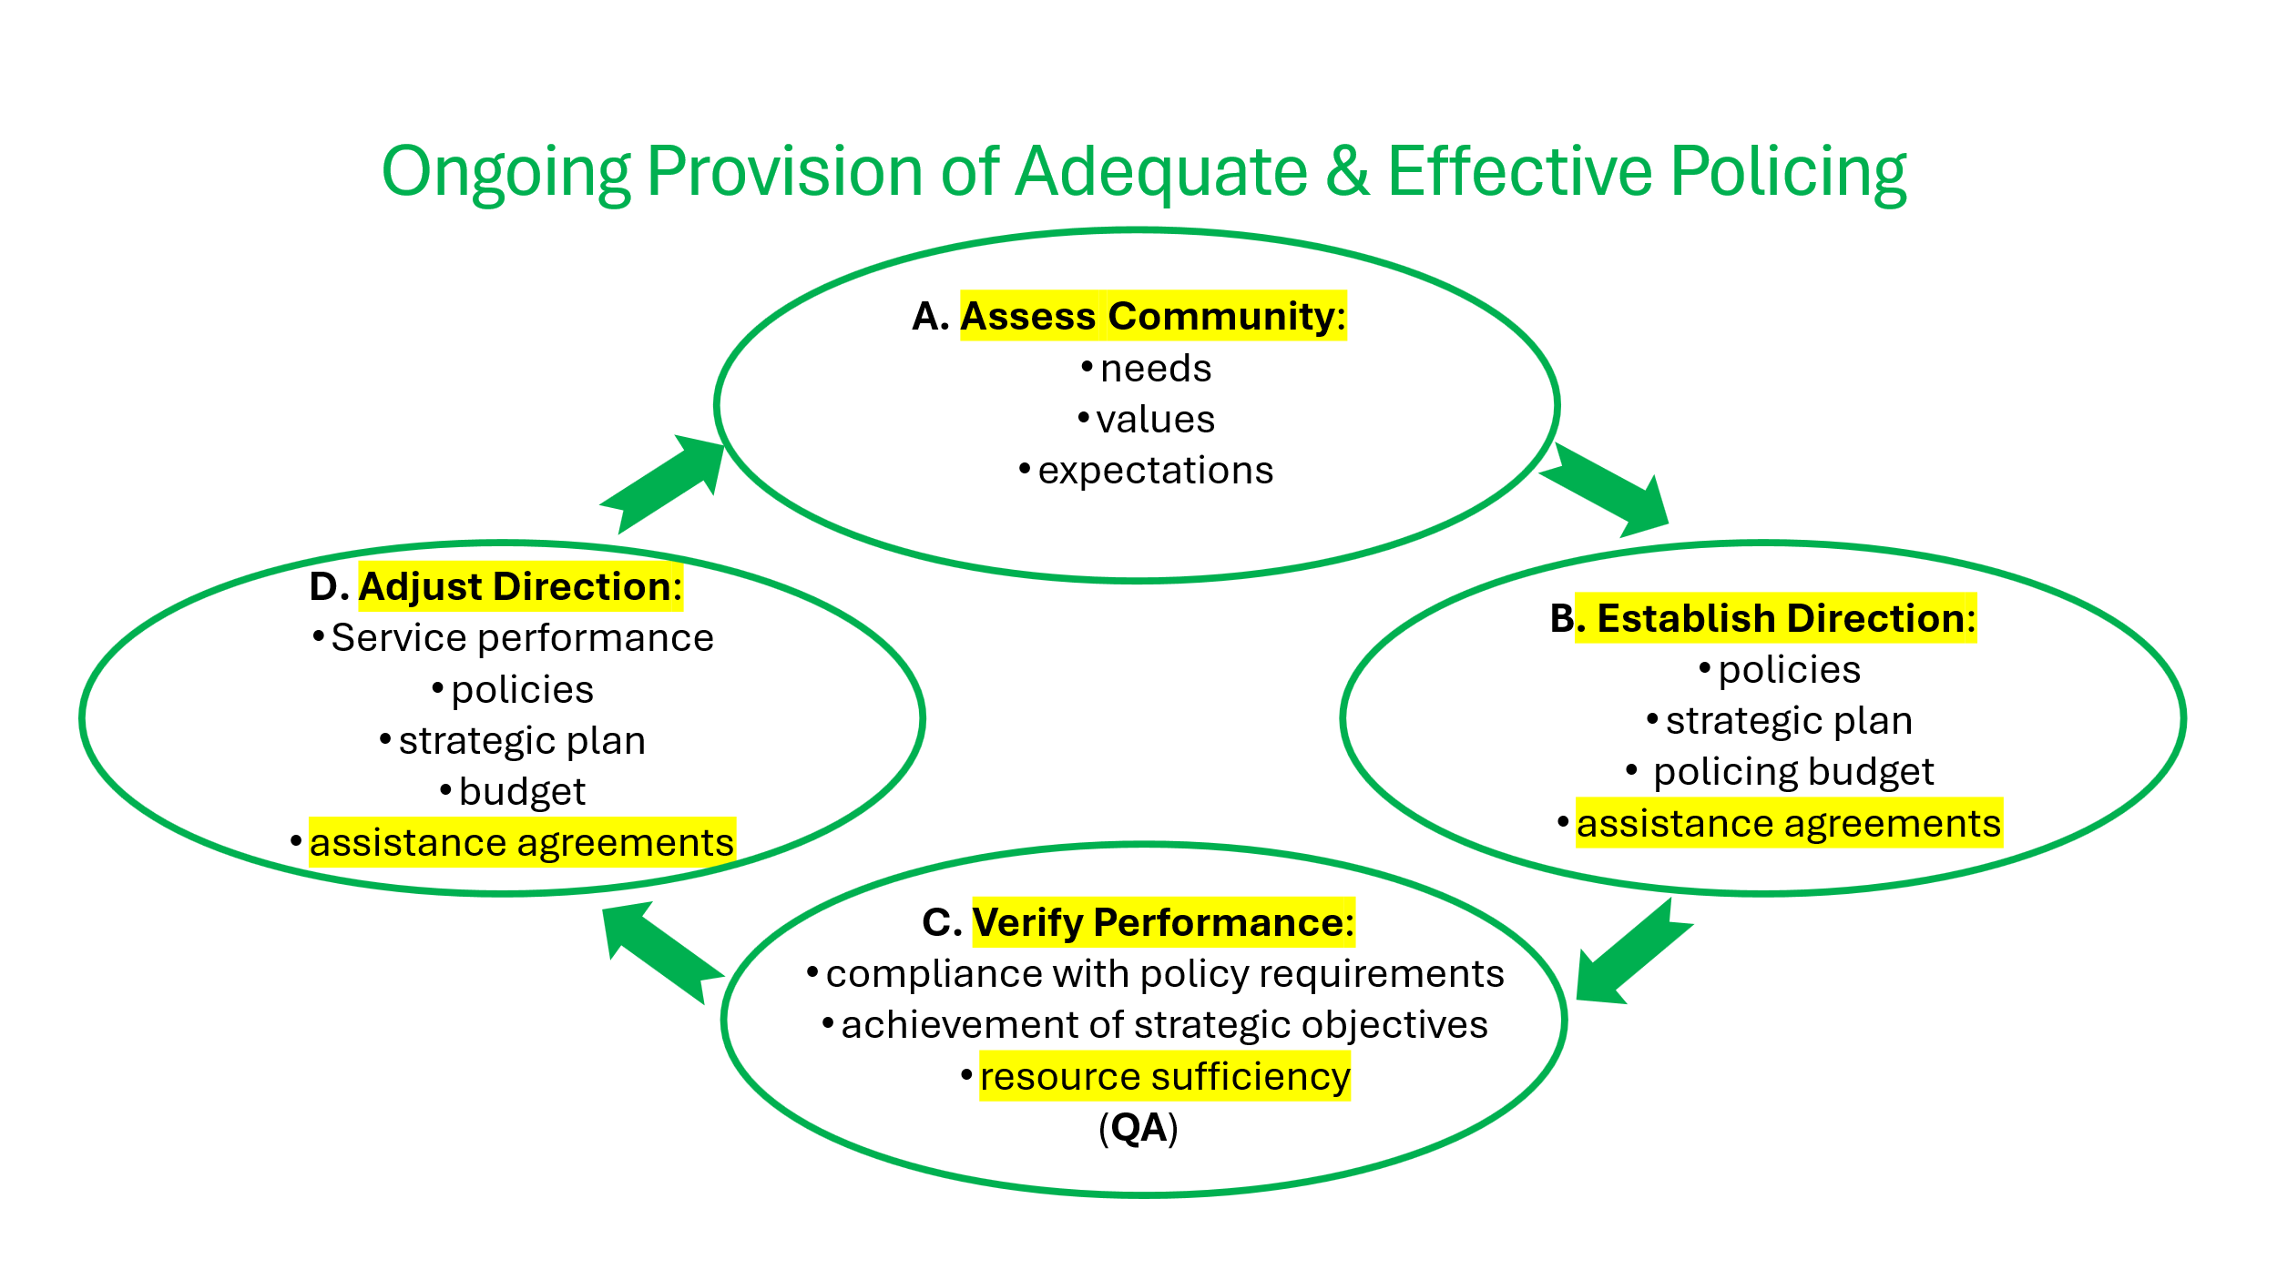

1. Conversely, the Board may be requested by another police board to provide them with one or more HRPS policing functions to augment their own policing services on an ongoing or frequent basis, necessitating a standing **Policing Assistance Agreement** between the boards. The provision of HRPS services to other police services must also be monitored by the Board to ensure there is no undue impact on community safety in Halton Region and to fiscal fairness.
2. Additionally, the chief of police of another police service may request **Temporary Policing Assistance** from the HRPS. The Board needs visibility of such provisions as well, for the reasons stated above.
3. This policy articulates the Board’s expectations regarding the notification, negotiation, establishment and monitoring of standing **Policing Assistance Agreements**, and the notification of **Temporary Policing Assistance** arrangements and subsequent consideration of budget and/or Policing Assistance Agreement adjustments.
4. Nothing in this policy prevents the Chief of Police from deploying or receiving resources to assist another policing jurisdiction as Temporary Policing Assistance or in an Emergency (CSPA s19), or participating in joint forces or other cross-jurisdictional operations.

**Requirements – (Standing) Policing Assistance Agreements** (s14)

1. The Chief of Police shall:
2. promptly inform the Board via a written report at the first available Board meeting whenever an HRPS policing function requires ongoing or frequent provision, in whole or in part, from another policing agency, or is approached by another police service for such ongoing support. That report shall include:
3. policing functions to be provided/received;
4. policing agencies involved;
5. potential impact on adequate and effective policing in Halton, if any;
6. the proposed duration of the agreement;
7. training implications;
8. equipment implications;
9. policy implications and recommendations;
10. procedural implications;
11. risk mitigation plans, including compliance with legislation and Board policies; and
12. cost implications and/or any cost recovery provisions.
13. The Chief of Police shall assist with the negotiation and development of any Policing Assistance Agreement, consistent with any Board direction on the matter.
14. The Board shall be the sole authorizing agent of any standing HRPS-related Assistance Agreement made under section 14 of the CSPA.
15. The Chief Police shall monitor and record all ongoing costs associated with assistance provided and received under the Policing Assistance Agreements.

**Requirements – Temporary Policing Assistance** (s19)

1. The Chief’s notice of Request for Temporary Policing Assistance serves to inform the Board of an emerging event related to the Provision of Policing **for receipt and discussion at the next meeting, and not before** (as per the Procedural By-law and Governance polices, particularly G-11 Chief-to-Board Communications). Accordingly, the Chief of Police shall:
2. inform the Inspector General and the Board (through the Manager of Board Operations) of any request for the Temporary Policing Assistance of another policing agency(s) beyond that provided for in the Board’s standing Policing Assistance Agreements, **within of 24 hours of any such request** (the IG-recommended time frame); and
3. monitor and record all costs associated with Temporary Policing Assistance provided and received under the Chief’s authority.

**Monitoring and Reporting Requirements**

1. In addition to the reporting requirements noted above regarding initiating Policing Assistance Agreement negotiations (para 7.1) and notification of Temporary Policing Assistance requests (para 11.1), the Chief of Police shall:
2. Provide an annual report regarding standing (section 19) **Policing Assistance Agreements**, in accordance with the Board’s Governance Calendar, that provides:
3. a summary of the assistance received by the HRPS, delineated by policing function, and the aggregate cost of assistance received;
4. a summary of the assistance provided by the HRPS, delineated by policing function, the aggregate cost of that assistance, and the status of cost recovery;
5. an assessment of the net impact of Policing Assistance to and from the HRPS on adequate and effective policing in Halton Region;
6. any unintended consequences incurred as a result of Policing Assistance to and from the HRPS under these Agreements, and steps taken to mitigate future risks;
7. any non-compliance with legislation and Board policies;
8. any recommendations to increase (or decrease) inherent HRPS capacity; and
9. recommended continuation, amendment or termination of each standing Policing Assistance Agreement.
10. Provide a semi-annual report regarding **Temporary Policing Assistance** (under section 19), in accordance with the Board’s Governance Calendar, that provides:
11. a summary of the assistance received by the HRPS, delineated by policing function, and the aggregate cost of assistance received;
12. a summary of the assistance provided by the HRPS, delineated by policing function, the aggregate cost of that assistance, and the status of cost recovery;
13. an assessment of the net impact of Temporary Policing Assistance to and from the HRPS on adequate and effective policing in Halton Region;
14. any unintended consequences incurred as a result of Policing Assistance to and from the HRPS under these Agreements, and steps taken to mitigate future risks;
15. any non-compliance with legislation and Board policies;
16. any recommendations to increase (or decrease) inherent HRPS capacity; and
17. any recommendations to establish/amend standing (section 14) Policing Assistance Agreements.
18. The Board shall annually verify, as part of its Quality Assurance (QA) Plan:
    1. legislative and Board-policy compliance of standing Policing Assistance Agreements and Temporary Policing Assistance actions;
    2. the impact of standing Policing Assistance Agreements and Temporary Policing Assistance actions on adequate and effective policing in Halton Region; and
    3. the cost effectiveness of standing Policing Assistance Agreements and Temporary Policing Assistance actions.
19. The Board shall subsequently direct any corrective action it deems appropriate regarding performance, policies, agreements or budgets.

**References**:

* *CSPA 2019*, s.10, 14, 19
* PoP-01 Provision of Adequate & Effective Policing
* PoP-04 Quality Assurance
* G-07 Governance Calendar