**Policy PoP-01**

**Provision of Adequate & Effective Policing**

Approved 22 May 2025

**Purpose**

1. Everyone in Halton Region has the right to receive adequate and effective policing, both directly and indirectly, in terms of policing functions provided, response times and quality of services.
2. Halton Police Board is responsible to provide adequate and effective policing to the community of Halton Region [CSPA s10]. This policy describes how the Board shall fulfill that role on an ongoing basis, and serves as the important context to all other policies related to the Provision of Policing.

**Requirements**

1. **General**. The Board’s on-going methodology for assessing, establishing, verifying, funding and modifying-as-required the HRPS capabilities, responsiveness and parameters (collectively referred to as “capacity”), as well as the strategic outcomes of policing functions, is depicted below:

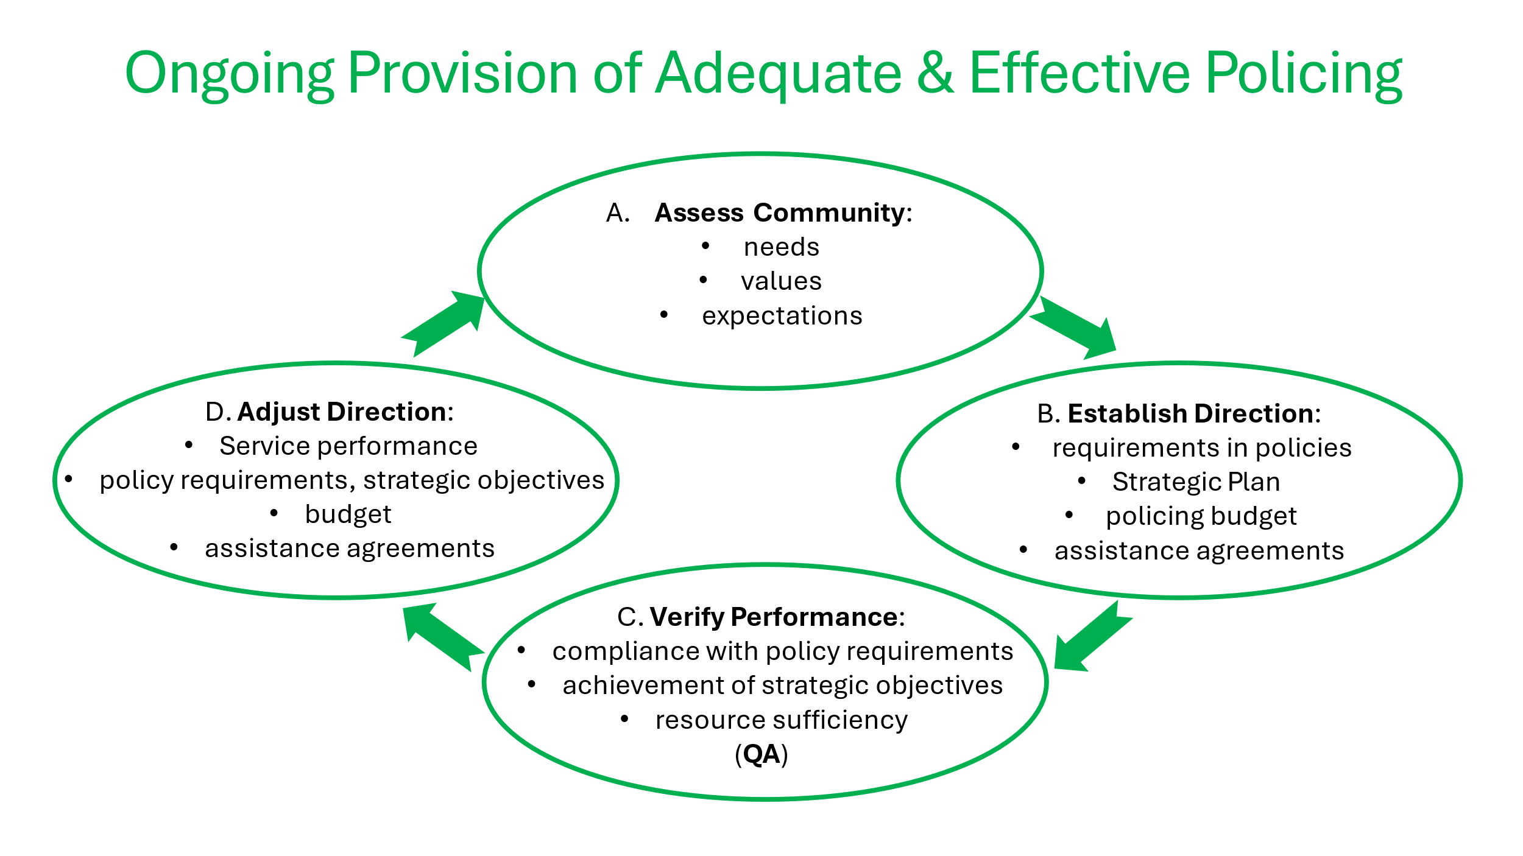

1. Policing functions are identified in regulations. In Halton Region, each policing function will be provided to a reasonable extent and in a reasonable manner. The Board shall determine the level of reasonableness by considering [O. Reg. 392/23 GAS s2(1)]:
2. the policing needs, values and expectations of the Community;
3. the geographic and socio-demographic characteristics of the Community;
4. the extent to and manner in which each policing function is effectively provided in comparator (Big 12) communities;
5. the effectiveness of past provision of each policing function in the Community, relative to Community needs, values and expectations; and
6. best practices regarding each policing function.

**Requirements of the Board**

1. **Determine Adequate & Effective Policing Requirements.** The Board shall determine Halton Region’s Adequate & Effective Policing requirements by:
2. observing the standards for adequate and effective policing as identified within O. Reg. 392/23;
3. receiving reports regarding the assessment inputs identified in the table below;
4. identifying gaps, surpluses, trends and risks based on those reports;
5. considering options to address gaps, mitigate risks and reallocate surpluses; and
6. selecting the most reasonable option.

|  |  |
| --- | --- |
| **Assessment Factor** | **Frequency** |
| Provincial regulations | Ongoing |
| IG directions & recommendations | Ongoing |
| Public inquiries & coroners inquests’ recommendations | Ongoing |
| Substantiated policy & service complaints | Ongoing |
| New best practises | Ongoing |
|  |  |
| Weighted crime rates & trends | Annually |
| Weighted clearance rates | Annually |
| Policing costs | Annually |
| Alternative, temporary and emergency assistance activities (assistance to or from other service providers) | Annually |
| Quality Assurance process findings | Annually |
|  |  |
| Progress on current Strategic Plan Objectives | Annually |
| Community needs, values & expectations via public survey, focus groups, letters | Every 4 years |
| Region geographic & socio-demographic characteristics | Every 4 years |

1. **Establish Provision of Policing Direction**
2. Provision of Policing Policies.Based on the ongoing and annual analysis of Adequacy & Effectiveness requirements above, the Board will establish (or revise) its Provision of Policing policies regarding specific policing functions. These policies establish minimum capabilities and readiness, and strategically frame policing activities in Halton Region (as envisioned by Morden). These policies will also address any alternate provisions for policing functions as applicable. [*CSPA alternate provision s14; temporary assistance and emergency assistance s19*]
3. Strategic Plan.Based on the once-every-4-year assessment of community needs, values and expectations and updated geographic & socio-demographic characteristics and projections for Halton Region, as well as progress on current Strategic Plan objectives and relative statistical performance data, the Board will establish a Strategic Plan for attaining specific strategic results-based objectives for the next 4-year cycle. Refer to Policy PoP03 Strategic Planning.
4. Establish Budgets. The Board shall establish annual operating and multi-year capital budgets that reflect its Provision of Policing policies and Strategic Plan for the HRPS, plus the administrative overhead, executive leadership and governance to ensure policing success. In essence, this is the budget rationale and global ROI.
5. Alternative Provision Agreements. Where the board’s assessment is that a prescribed policing function should be provided, or part of a policing function (including ad hoc or occasional assistance) by another board or the Commissioner, a formal Board-to-Board Assistance Agreement shall be established in accordance with s.14 of the CSPA.
6. Temporary Assistance. Service delivery may also be supplemented by alternative service providers on a temporary basis when and where such need is determined by, and arranged for by, the Chief of Police in accordance with s.19 of the CSPA.
7. **Verify Performance.** In accordance with policy PoP03 - Quality Assurance, the Board shall verify organizational performance by undertaking Quality Assurance processes regarding Emergency Response:
8. compliance with the Board’s Provision of Policing policies, and
9. attainment of Strategic Plan objectives.
10. **Adjust Direction**. Based on the results of Verifying Performance, the Board may direct any of the following adjustments:
    1. corrective action by the HRPS;
    2. adjustments to policy requirements;
    3. adjustments to Strategic Plan;
    4. adjustments to the Budget; and/or
    5. adjustments to Assistance Agreements.

**Monitoring and Reporting Requirements**

1. **Internal Reporting**. Internal reporting requirements regarding Adequacy & Effectiveness are outlined in the various Provision of Policing policies and scheduled in policy G07 Governance Calendar.
2. **Public Reporting**. All Board policies and Strategic Plans shall be posted on the internet. Public reporting requirements regarding HRPS performance are addressed in policy PoP05 Annual Report.

**References**:

* CSPA Board role, shared services, temporary assistance (s10, s14, s19)
* [O. Reg. 392/23](https://www.ontario.ca/laws/regulation/r23392) Adequate and Effective Policing (General)
* HPB Policies G01 Governance Commitment. G02 Board Job Description, G07 Governance Calendar, PoP03 Strategic Planning, PoP04 Quality Assurance, PoP05 Annual Report